Task 2: Discipline and confederation
Introduction and research question
This task looks at team discipline, specifically, whether UEFA (European) teams picked up yellow cards at a different rate than teams from every other confederation combined. Discipline hasn't been covered by the group's other tasks, which focus on playing time and possession, so it gives us a genuinely separate angle on the tournament.
Research question: among the 48 teams that played at the 2026 World Cup, did UEFA teams receive a significantly different average number of yellow cards per match than non-UEFA teams?
Data preparation
Yellow card totals for each team came from FotMob's World Cup 2026 team statistics pages. FBref would have been the preferred source, but its team-level pages block automated access, so FotMob was used instead. Matches played per team wasn't given directly, so this was worked out from how far each team went in the tournament: 3 matches for a group-stage exit, 4 for a Round of 32 exit, 5 for Round of 16, 6 for the quarter-finals, and 8 for the two semi-final losers (who also play the third-place match) and the two finalists.
Raw card totals aren't directly comparable, since teams that went further simply played more matches and had more chances to pick up cards. To fix this, cards were divided by matches played to get a cards-per-match rate, and each team was tagged as UEFA or Non-UEFA.
Population and sampling
The population here is all 48 teams that competed (16 UEFA, 32 non-UEFA). From that, a simple random sample of 34 teams was drawn without replacement, about 71% of the population, using a fixed seed (42) so the result can be reproduced. That gave 12 UEFA teams and 22 non-UEFA teams in the sample. Each row in the analysis is one team, and the variable we're measuring is that team's yellow cards per match.
Descriptive statistics
Table 1 shows the sampled cards-per-match rate for each group.
Group | n | Mean | SD | Min | Max
UEFA | 12 | 0.936 | 0.392 | 0.333 | 1.750
Non-UEFA | 22 | 1.492 | 0.481 | 0.750 | 2.400
Table 1. Yellow cards per match by confederation group (sample, n=34).
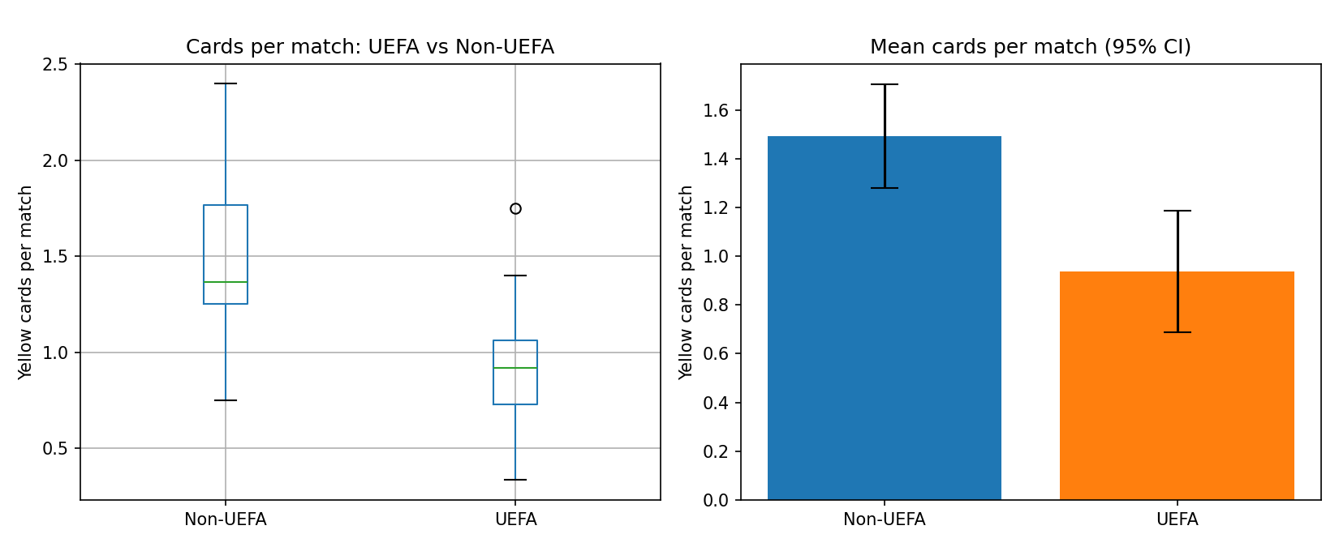
Figure 1. Distribution and mean (95% CI) of yellow cards per match, UEFA vs Non-UEFA.
Confidence interval and hypothesis test
For the whole sample (all 34 teams together), the 95% confidence interval for mean cards per match works out to 1.114 to 1.478 (sample mean = 1.296, n = 34).
To compare the two groups, the null hypothesis was that UEFA and non-UEFA teams have the same mean cards-per-match, with the alternative being that they differ. Welch's two-sample t-test was chosen over the standard t-test since it doesn't assume the two groups have equal variance, which fits here given how different the two group sizes and spreads are. Alpha was set at 0.05.
The test returned t = -3.638, p = 0.0011. That's well under 0.05, so the null hypothesis is rejected. Non-UEFA teams averaged 1.492 cards per match, clearly higher than UEFA's 0.936.
Interpretation and Limitations
So non-UEFA teams picked up noticeably more cards per match than UEFA teams did. It's tempting to read this as a style-of-play difference, or maybe something about how referees from different confederations call fouls, but the data here can't actually tell us why, only that there's a real gap.
A confederation is a pretty blunt grouping, it lumps together teams that play very differently from one another, so this result shouldn't be read as saying anything about a specific team. The cards-per-match figure also can't tell us when in a match the fouls happened, or whether some teams simply faced tougher opponents (teams that went deep into the knockouts played harder games on average than ones knocked out early).
Lessons learned
The main hiccup was FBref blocking automated requests, which meant switching to FotMob partway through. It's also easy to miss that raw card counts aren't comparable across teams once some have played 8 matches and others only 3, converting to a rate fixed that but it's a step worth double-checking in any similar analysis.
Conclusion
In this sample, UEFA teams averaged 0.936 cards per match against 1.492 for non-UEFA teams, a difference that held up statistically (t = -3.638, p = 0.0011). That said, the limitations above, especially the broad confederation grouping, mean this is a tournament-level pattern rather than a claim about any individual team.
Reference
FotMob. (n.d.). FIFA World Cup 2026 team statistics, total yellow cards. Retrieved September 2026, from https://www.fotmob.com/leagues/77/stats/season/24254/teams/total_yel_card_team/world-cup-teams
Task 3: Possession and knockout progress
Introduction and research question
This task turns to possession, and specifically whether teams that made it to the quarter-finals or beyond controlled the ball more, on average, than teams knocked out earlier (Round of 32 or Round of 16). Possession as a playing style hasn't come up in the group's other tasks, so it rounds out the set with something on how teams actually played rather than just how disciplined or fit they were.
Research question: among the 32 teams that reached the knockout stage, did teams advancing to the quarter-finals or further have significantly higher average possession than teams eliminated in the Round of 32 or Round of 16?
Data preparation
Average possession per team came from FotMob again, but only for the 32 teams that reached the knockout stage, teams knocked out in the groups don't get a full-tournament possession average tracked on that platform. Each of the 32 was then labelled 'Quarterfinal+' or 'Early exit' by checking the actual Round of 16 and quarter-final results.
The two pieces (possession and progress) were merged into one 32-row dataset in Python. No missing values turned up, so nothing needed to be dropped.
Population and sampling
Population: the 32 teams that reached the knockouts, 8 of which made the quarter-finals or further and 24 of which didn't. A simple random sample of 24 teams (75%) was drawn without replacement, seed = 7 for reproducibility, giving 6 quarterfinal-or-further teams and 18 early-exit teams in the sample. Again, each row is one team, and the outcome we care about is average possession across the tournament.
Descriptive statistics
Table 2 shows the sampled average possession for each group.
Group | n | Mean (%) | SD | Min (%) | Max (%)
Quarterfinal+ | 6 | 56.27 | 4.19 | 52.2 | 64.0
Early exit | 18 | 48.90 | 9.33 | 29.7 | 65.2
Table 2. Average possession (%) by knockout progress group (sample, n=24).
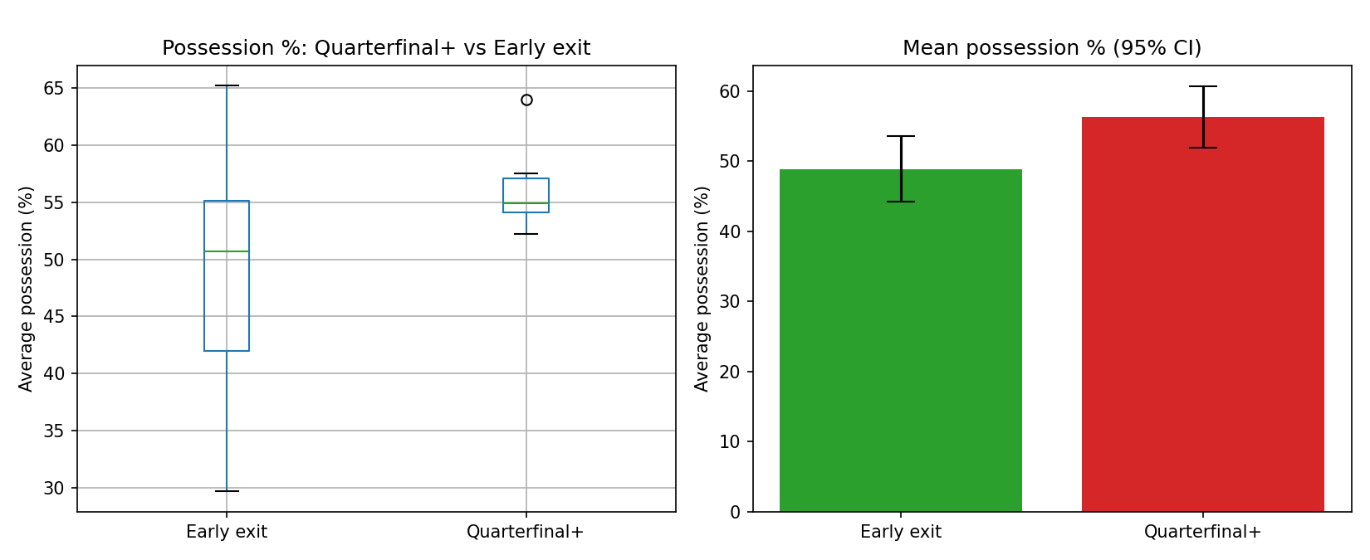
Figure 2. Distribution and mean (95% CI) of average possession (%), Quarterfinal+ vs Early exit.
Confidence interval and hypothesis test
Across all 24 sampled teams, the 95% confidence interval for mean possession comes out to 47.00% to 54.49% (sample mean = 50.68%).
Null hypothesis: quarterfinal-or-further teams and early-exit teams have the same mean possession. Alternative: they don't. As with Task 2, Welch's two-sample t-test was used because it doesn't require equal variances between the two groups, and alpha was again 0.05.
Result: t = 2.646, p = 0.0157, so the null hypothesis is rejected. Quarterfinal+ teams averaged 56.27% possession, meaningfully above the 48.90% for teams that exited earlier.
Interpretation and limitations
Teams that kept the ball more tended to go further, which lines up with what most football analytics generally find, possession correlates with control of a match. That's not the same as saying possession caused the deeper runs though; teams that are already better tend to both keep the ball more and win more, so this result is descriptive rather than causal.
Worth flagging: only 8 teams reached the quarter-finals in the whole population, and just 6 landed in this sample, so that group's average is based on very few teams and could shift a fair bit with a different random draw. Possession also says nothing about what a team does with the ball, whether it's translating into shots or just sideways passing, and it doesn't account for some teams facing easier knockout draws than others.
Lessons learned
The original plan was actually to compare knockout teams against group-stage-only teams, but it turned out FotMob simply doesn't publish full-tournament possession for teams eliminated in the groups. So the question got reframed around how far teams went within the knockouts, rather than knockout vs. group stage, once that gap in the data became clear.
Conclusion
Quarterfinal+ teams in this sample averaged 56.27% possession versus 48.90% for early-exit teams, and the difference was statistically significant (t = 2.646, p = 0.0157). Given how small the quarterfinal+ group is, this should be read as a solid pattern rather than a precise estimate.
Reference
FotMob. (n.d.). FIFA World Cup 2026 team statistics, average possession and total yellow cards. Retrieved September 2026, from https://www.fotmob.com/leagues/77/stats/season/24254/teams/

